Post Harvesting / Threshing

## Wheat Thresher

**Category:** Harvesting & Threshing

**Tags:** PTO Operated Threshing

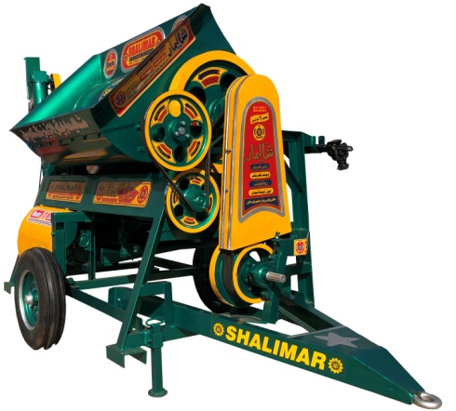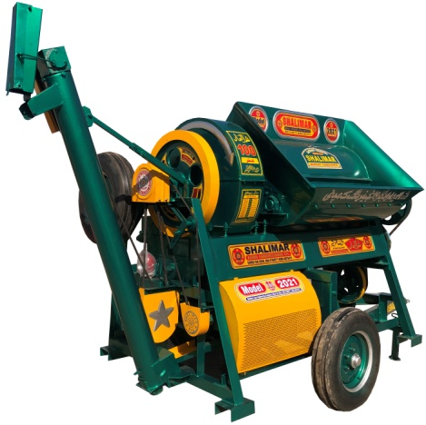

## Description

A wheat thresher is used to thresh wheat & mustard grains, it removes the seeds from stalks and husks. It does so by beating the dried plant to make the seeds fall out. Earlier than such equipments were developed, threshing was done by hand with flails.

Shalimar wheat thresher is more cost effective in terms of equipment & operational cost. It has enhanced cleaning and threshing performance with incredibly low fuel consumption. The straw and chaff removed from crops are costly things & useful for live stock food as silage.

Wheat thresher is operated through two options, Tractor PTO & diesel engine PTO and transported through trailer hook. The equipment weight provides it a great flexibility in threshing operations from one field to another by simple trailing hook. It is simple to operate, required low maintenance and easy interior examination makes this field proven design a preferred & most wanted of small farmers throughout the world. Mainly it is suitable for Asian & African countries.

Also available with delivery conveyor (optional)

|  |  |  |
| --- | --- | --- |
| Specifications | | |
|  | Simple | With Conveyor |
| Capacity | 1800 KG / hr | |
| No. of Steel Cutters | 100 | |
| Length of Drum | 54'' | |
| Width of Drum | 28’’ | |
| PTO Cross Shaft | 1 (Optional Small/Long) | |
| No of PULLIES | 9 | 10 |
| No of Belts | 9 | 10 |
| Spare Tyre | 1 | |
| Balance Wheel | 2 | |
| Blower | 2 | |
| Sieves | 4 | |
| Length | 12.5 ft | 15 ft |
| Width | 78'' | |
| Height | 90'' | |
| Grain Breakage: | ~ 0 | |
| Power Requirement: | 50HP | |
| Labour Requirement: | 4 | 3 |
| PTO Speed: | 700 - 750 RPM. | |
| Tyre type | 600-16 | |
| Weight | 1700 KG | 1820 KG |
| Fuel Consumption: | * 1. – 6.5 L/hr | |

## Multi Purpose Gram Thresher

**Category:** Harvesting & Threshing

**Tags:** PTO Operated Threshing

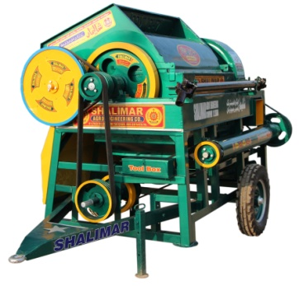 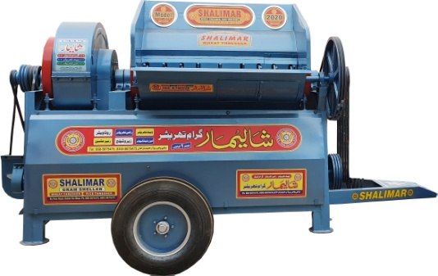

## Description

A multipurpose Gram thresher is a multi crop thresher which is widely being used to separate grams from the harvested crop. It can also be used for threshing lentils, chickpeas, mustard and wheat crops. Threshers are popular because Small land farmers can’t buy combine harvesters as it is very expensive, whereas threshers are much more economical.

Shalimar gram thresher is extra cost effective in terms of equipment & operational cost. It has enhanced cleaning and threshing performance with extremely low fuel consumption.

Gram thresher is operated through two options, Tractor PTO & diesel engine PTO and transported through trailer hook. The equipment weight provides it a great flexibility in threshing operations from one field to another by simple trailing hook. It is simple to operate, required low maintenance and easy interior examination. Mainly it is suitable for Asian & African countries. Also available with delivery conveyor (optional)

|  |  |  |
| --- | --- | --- |
| Specifications | | |
|  | Simple Model | Advance Model |
| Capacity | 1800 KG / hr | |
| No. of Steel Cutters | 100 | 81 |
| Length of Drum | 60'' | |
| Width of Drum | 34’’ | |
| PTO Cross Shaft | 1 (Optional Small/Long) | |
| No of PULLIES | 13 | 12 |
| No of Belts | 14 | |
| Spare Tyre | 1 | |
| Balance Wheel | 4 | |
| Blower | 2 | |
| Sieves | 6 | |
| Length | 16 ft | 16.5 ft |
| Width | 72'' | |
| Height | 90'' | |
| Grain Breakage: | ~ 0 | |
| Power Requirement: | 50HP | |
| Labour Requirement: | 4 | |
| PTO Speed: | 350 - 700 RPM | |
| Tyre type | 750-16 | |
| Weight | 2000 KG | 2240 KG |
| Fuel Consumption: | 5.5 - 6.5   L/hr | |

## Rice / Paddy Thresher

**Category:** Harvesting & Threshing

**Tags:** PTO Operated Threshing

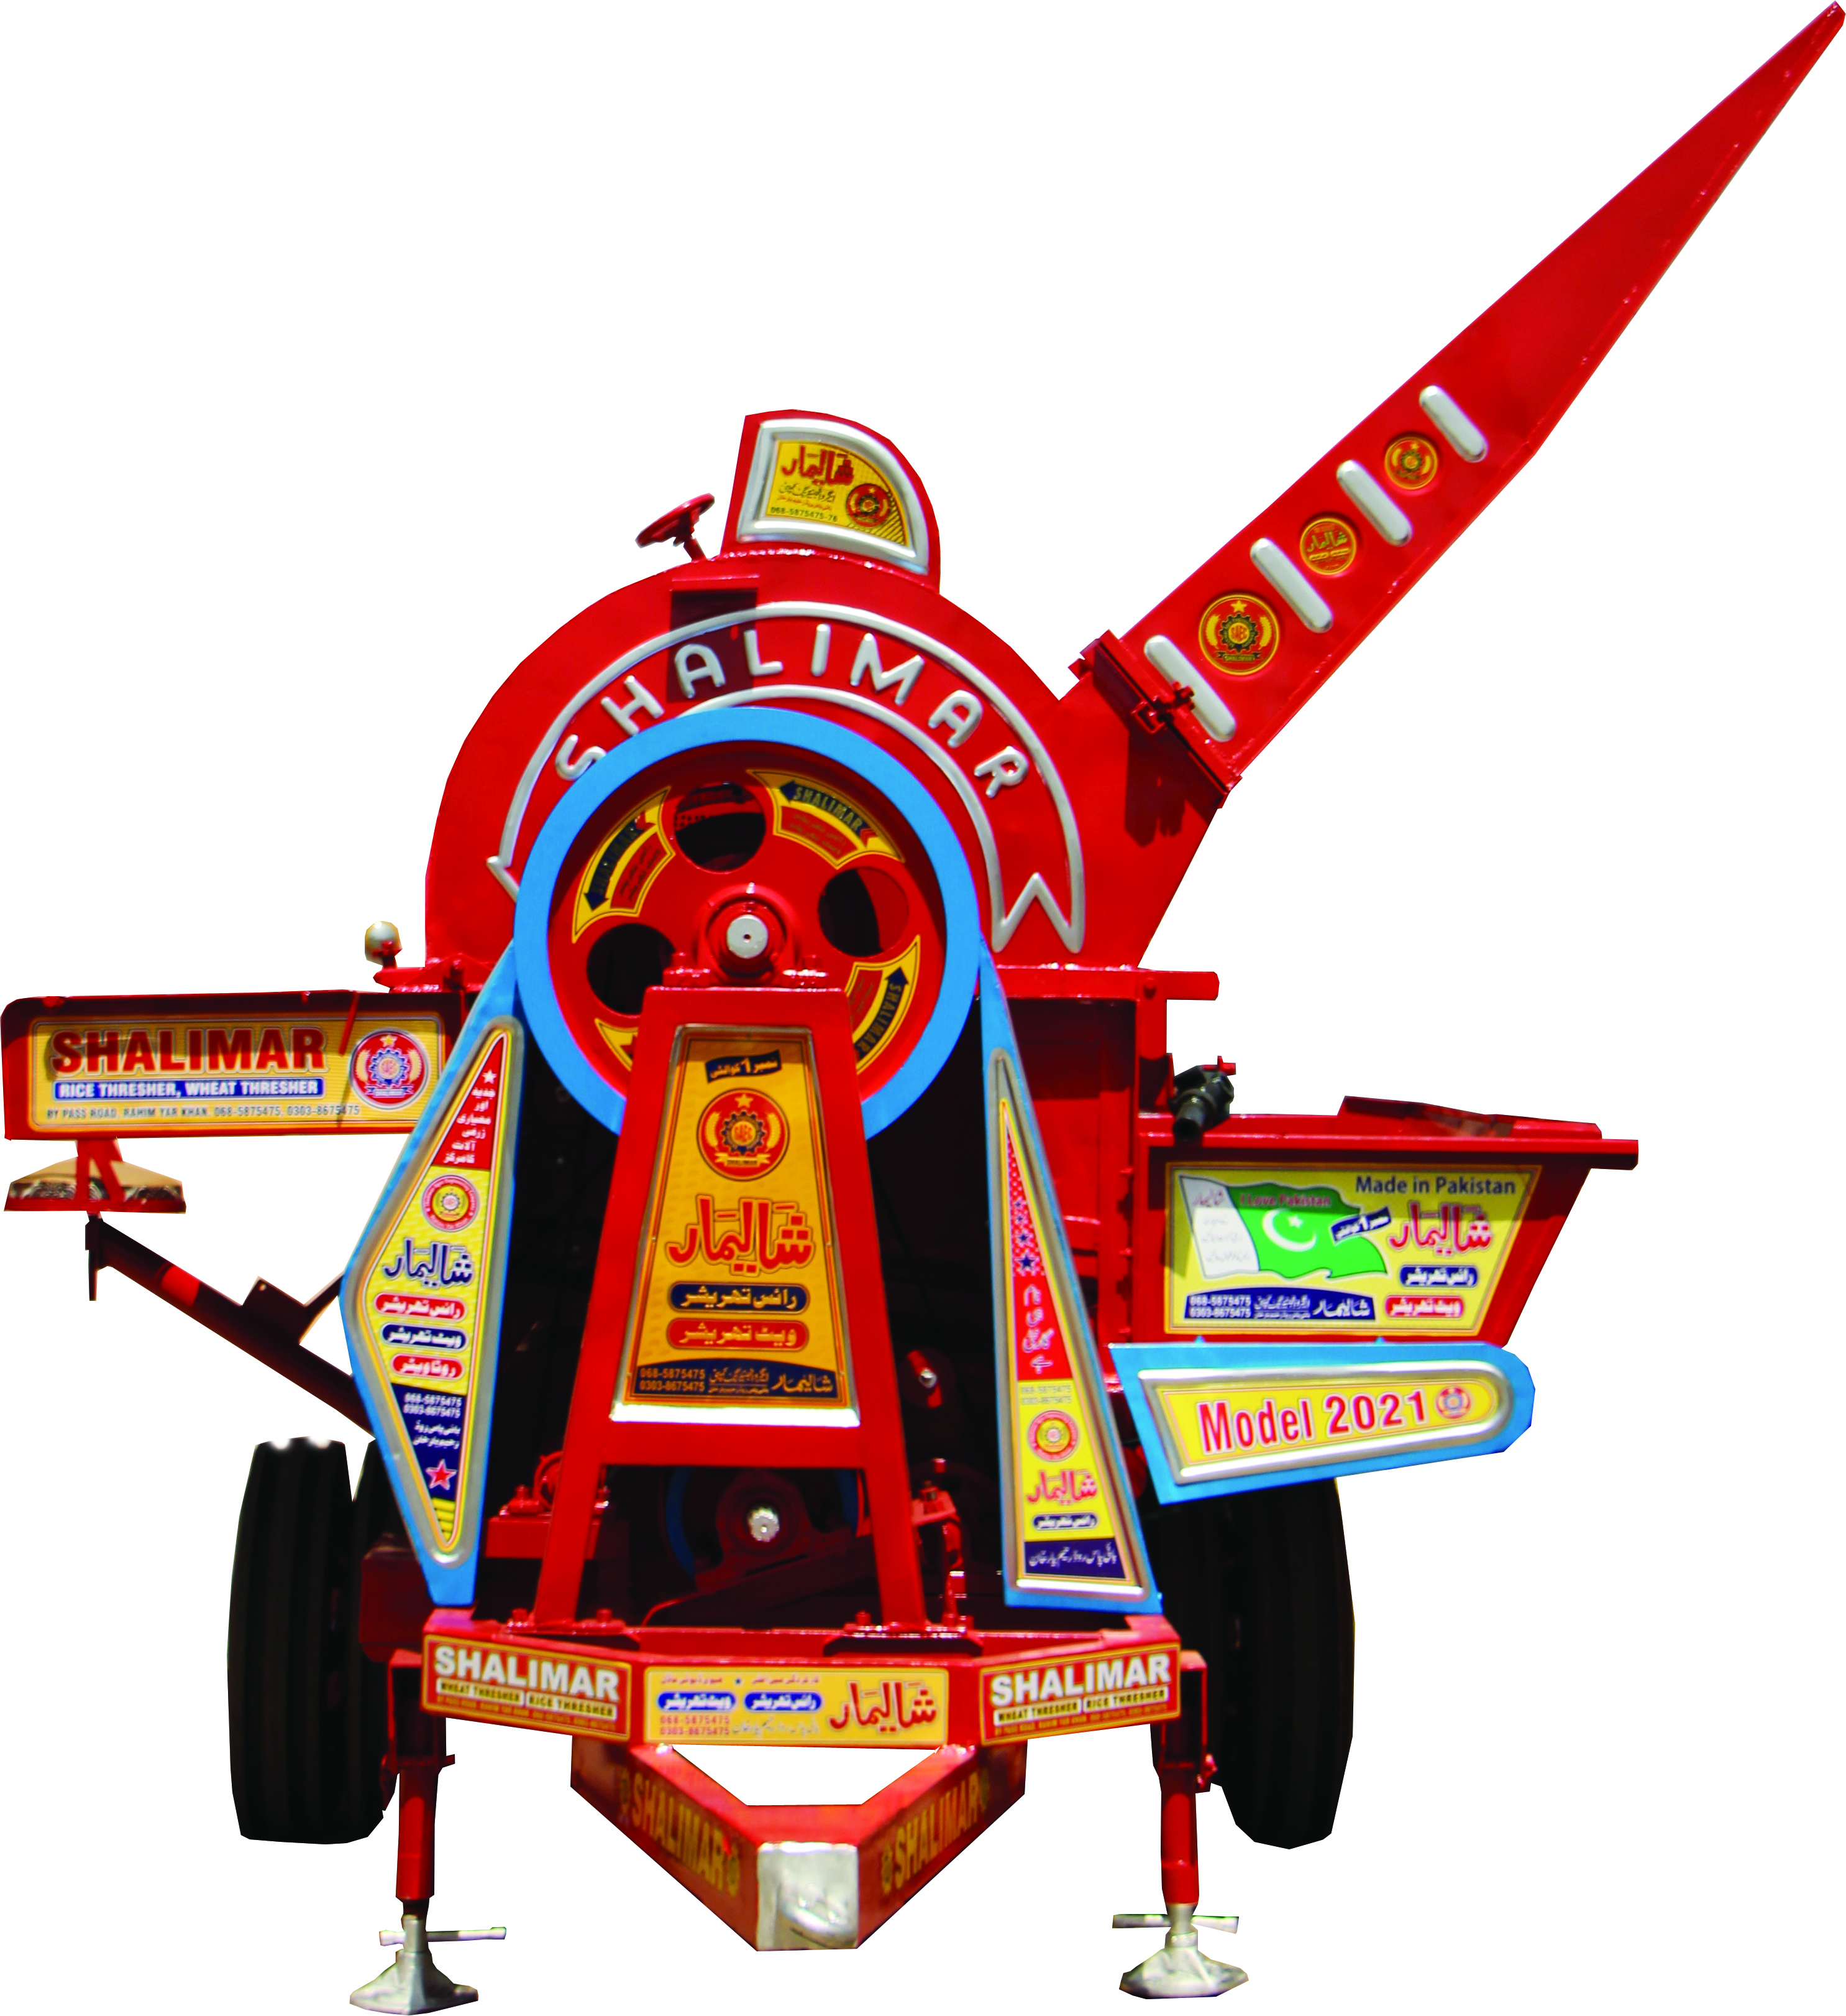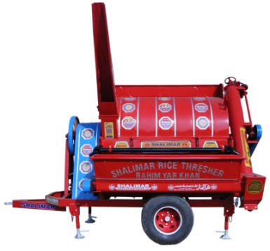

## Description

Shalimar Paddy threshers are manufactured by using high quality materials (iron sheets, casting & etc). It is designed uniquely that allows this equipment to gain extra output by maintaining less pressure on tractor than other threshing machines. It contains 4 blowers which & 2 sieves that provides extra cleaning for paddy crop.

Paddy thresher is operated through two options, Tractor PTO & diesel engine PTO and transported through trailer hook. The equipment weight provides it a great flexibility in threshing operations from one field to another by simple trailing hook. It is simple to operate, required low maintenance and easy interior examination. Mainly it is suitable for Asian & African countries. Also available with delivery conveyor (optional)

|  |  |  |
| --- | --- | --- |
| Specifications | | |
|  | 6 ft | 7 ft |
| Capacity | 1650 KG / hr | 2000 KG / hr |
| No. of Steel Cutters | 190 | 230 |
| Length of Drum | 72'' | 84'' |
| Width of Drum | 46'' | |
| PTO Cross Shaft | 1 | |
| No of PULLIES | 16 | |
| No of Belts | 15 | |
| Balance Wheel | 2 | |
| Blower | 4 | |
| Sieves | 2 | |
| Length | 15 ft | 16 ft |
| Width | 108'' | |
| Height | 118'' | |
| Grain Breakage: | ~ 0 | |
| Power Requirement: | 50HP | |
| Labour Requirement: | 4 | |
| PTO Speed: | 500 - 550 RPM | |
| Tyre type | 750-16 | |
| Weight | 2400 KG | 2600 KG |
| Fuel Consumption: | 5.5 - 6.5 L/hr | |

## Sunflower Thresher

**Category:** Harvesting & Threshing

**Tags:** PTO Operated post harvest thrashing implement

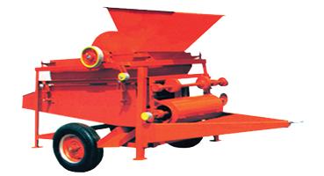

## Description

Sunflower thresher machine is a special machine for threshing sunflower seed from the disk. Through broken the sunflower disk make the seed drop down to the screen device. Then the screen device shakes to separate the seeds from the residue disk pieces. All the processing is safe, fast and clean. It can keep the seeds complete. It is simple reasonable structure, convenient in use, threshing effect is good, high efficiency, It can be fitted with PTO engine or tractor (50 HP). Mainly it is suitable for Asian & African countries.

|  |  |
| --- | --- |
| Specifications | |
| Capacity | 1500 - 2000 KG / hr |
| PTO Cross Shaft | 1 |
| No of PULLIES | 7 |
| Balance Wheel | 2 |
| Blower | 1 |
| Sieves | 3 |
| Length | 13 ft |
| Width | 72'' |
| Height | 90'' |
| Grain Breakage: | ~ 0 |
| Power Requirement: | 50HP |
| Labour Requirement: | 2 |
| Tyre type | 600 - 16 |
| Weight | 1100 KG |
| Fuel Consumption: | 4 - 5   L/hr |

## Millet Thresher (Bajri)

**Category:** Harvesting & Threshing

**Tags:** PTO Operated post harvest thrashing implement

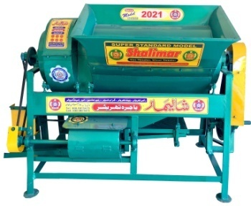 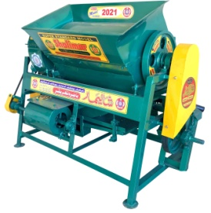

## Description

Millet is a cereal grain and millet thresher can be used to thresh flowering cereals like sorghum, millet and barley. Millet thresher removes the seeds from grain head and it does so by beating the dried grain head to make the seeds fall out. It has a better cleaning and threshing performance. It owns such advantages like compact structure, easy maintenance, good performance, almost zero loss rate, simple operation and high efficiency. It can be operated with two options, PTO engine or tractor (50 HP). Mainly it is suitable for Asian & African countries.

|  |  |
| --- | --- |
| Specifications | |
| Capacity | 600 - 800 KG / hr |
| PTO Cross Shaft | 1 |
| No of PULLIES | 8 |
| No of Belts | 6 |
| Balance Wheel | 2 |
| Blower | 2 |
| Sieves | 2 |
| Length | 82'' |
| Width | 40'' |
| Height | 58'' |
| Grain Breakage: | ~ 0 |
| Power Requirement: | 50HP |
| Labour Requirement: | 2 |
| Weight | 500 KG |
| Fuel Consumption: | 3 - 3.5 L/hr |